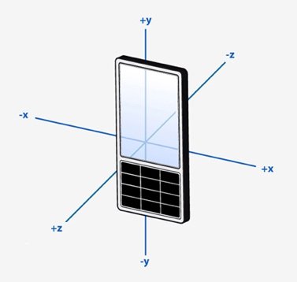

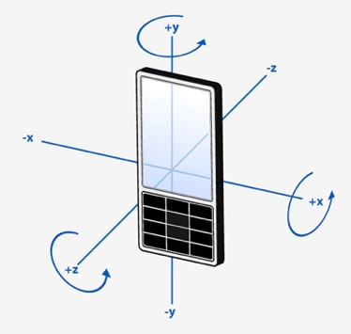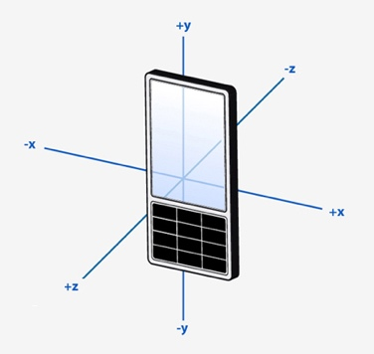

Accelerometer GYRO MAGNETOMETER

Z + x = Pitch Y = Pitch Z +x = Pitch

Y + x = Roll Z = Roll Y + x = Roll

X = Yaw X = Yaw Y + z = Yaw